

Impact of parent’s Educational Background on Child’s Academic Abilities

Prepared by: Kiran Neupane



June 28, 2023

thankot, Kathmandu

Kiran10neupane@gmail.com

# Table of Contents

Introduction 2

Dataset Description 3

Data Cleaning 4

Data Visualization 6

Data Analysis 7

Conclusion 8

References 9

# Introduction

The purpose of this report is to analyze the impact of Parent’s Educational Background on Child’s Academic Abilities using a dataset obtained from a public school. The study will focus on two key parameters: Parent’s Education and Child’s Cumulative Test Score. The data will be cleaned, visualized and analyzed using Python programming language and its associated libraries, including pandas, NumPy and Plotly.

# Dataset Description

The data set contains more than 30K entries which are divided into 15 categories as follows:

**Gender**: Gender of the student (male/female)

**EthnicGroup**: Ethnic group of the student (group A to E)

**ParentEducation**: Parent(s) education background (from some_highschool to master's degree)

**LunchType**: School lunch type (standard or free/reduced)

**TestPrep**: Test preparation course followed (completed or none)

**ParentMaritalStatus**: Parent(s) marital status (married/single/widowed/divorced)

**PracticeSport**: How often the student practice sport (never/sometimes/regularly))

**IsFirstChild**: If the child is first child in the family or not (yes/no)

**NrSiblings**: Number of siblings the student has (0 to 7)

**TransportMeans**: Means of transport to school (schoolbus/private)

**WklyStudyHours**: Weekly self-study hours (less that 5hrs; between 5 and 10hrs; more than 10hrs)

**MathScore**: math test score(0-100)

**ReadingScore**: reading test score(0-100)

**WritingScore**: writing test score(0-100)

**\*CumulativeTestScore:** Average of MathScore, ReadingScore and WritingScore(0-100)

*New column **CumulativeTestScore** was manually concatenated in the dataset

# Data Cleaning

1. Finding Null Values in the dataset

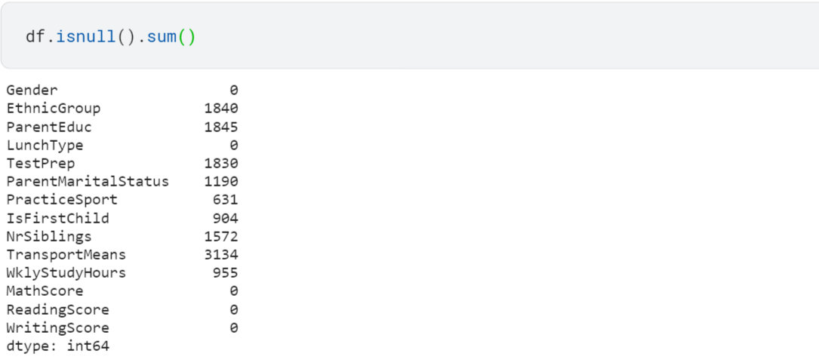

1. Replacing Null Values in the dataset

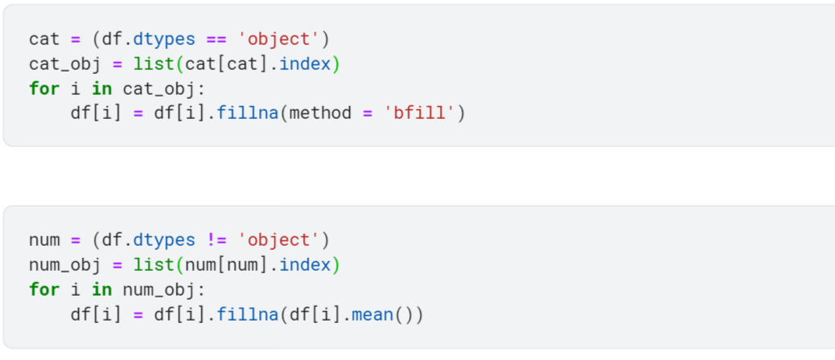

1. Calculating CumulativeTestScore

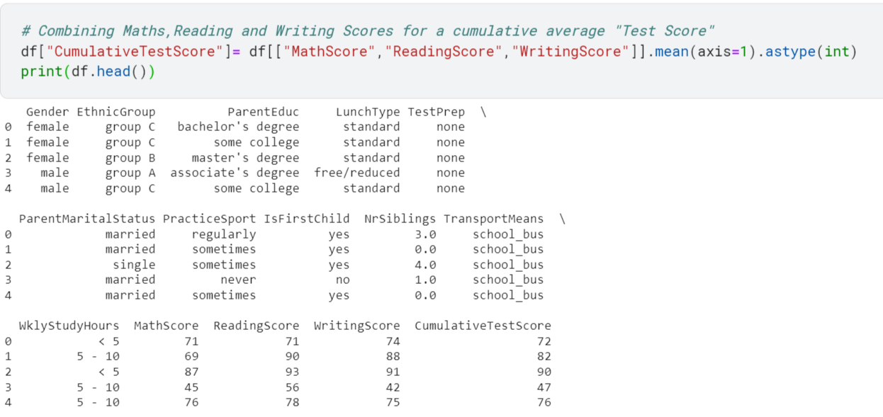

1. Calculating Correlation Matrix

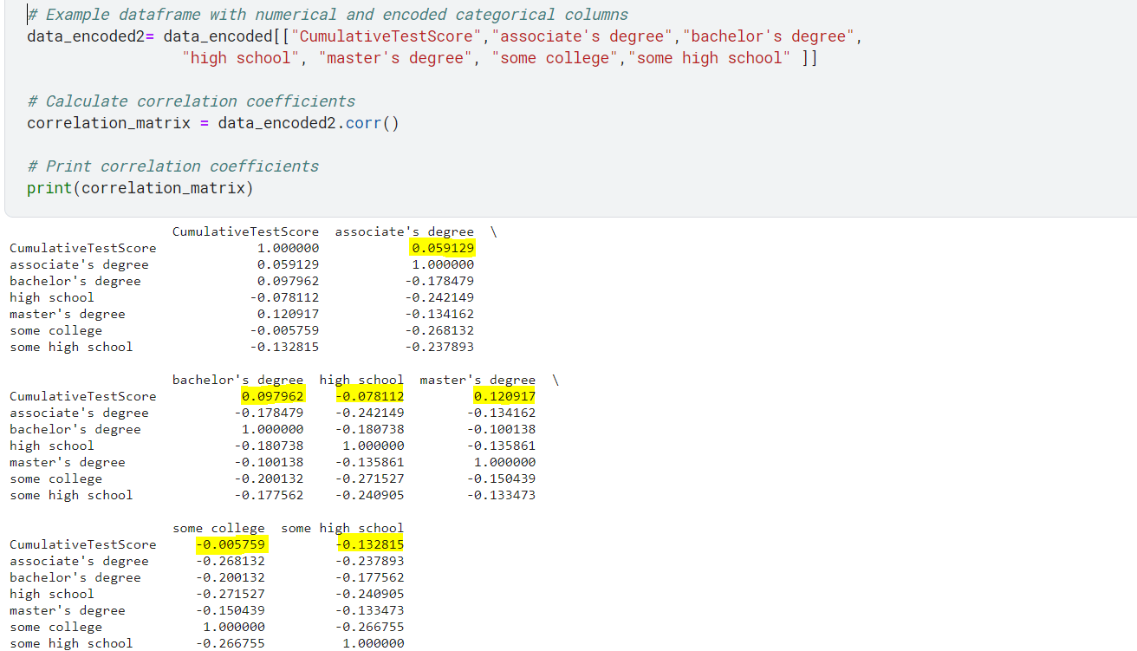

# Data Visualization

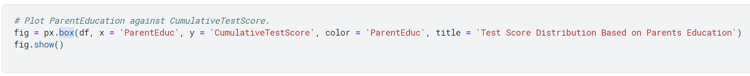

* Box Plot

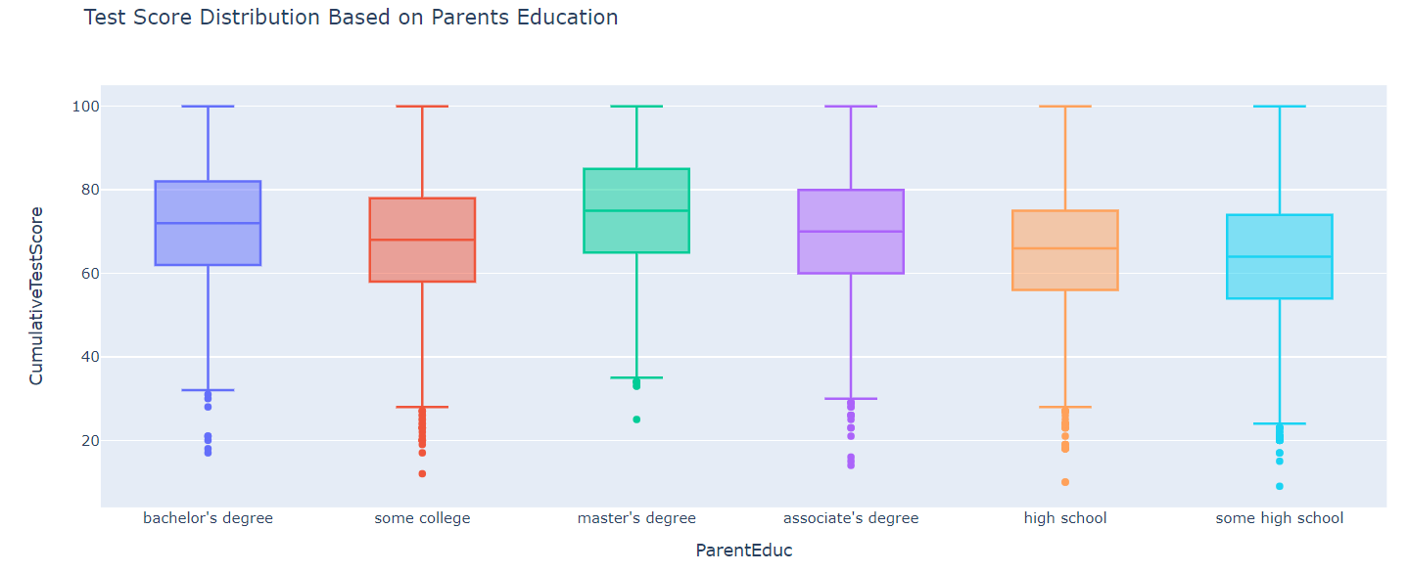 *Source:* [*Plotly.com*](https://plotly.com/)

# Data Analysis

Impact of Parent's Education Background on Students' Cumulative Test Scores

* A Positive Correlation between ParentEducation and CumulativeTestScore was observed among Parents with a degree (i.e. Master’s, Bachelor’s or Associate’s).
* A Negative Correlation between ParentEducation and CumulativeTestScore was observed among Parents without a degree (i.e. high school, some college or some high school).

# Conclusion

These findings underscore the importance of parental education as a significant factor in shaping students' academic success. It highlights the need for educational institutions and policymakers to focus on providing support and resources to students from families with lower educational backgrounds, as they may face additional challenges in achieving academic excellence.

## References

[1] "Plotly." Available online: <https://plotly.com/>. [Accessed: June 28, 2023].

[2] "Kaggle." Available online: <https://www.kaggle.com/>. [Accessed: June 28, 2023].